TPN Compliance for Log360
Strengthen cybersecurity and meet TPN compliance with Log360.
Region: USA, International | Type: Industry Standard, Incident Management, Media/Entertainment | Category: Compliance | Pricing: Free

Overview
The TPN compliance extension in Log360 helps organizations meet the Trusted Partner Network (TPN) Assessment, the media industry's content security program administered by MPA using Content Security Best Practices v5.3 across Organization, Physical, Technical, and Operational Security domains by providing centralized log management, access auditing, and threat detection. The platform supports TPN requirements for security governance, content asset monitoring, system hardening, network security, vulnerability management, and incident response.
For Organization Security - Governance and Personnel, Log360 monitors GPO auditing, Entra ID policy and directory management, role management, user auditing, Entra ID user management, and AD group auditing to demonstrate governance controls and personnel role assignments across content-handling environments. To address Content Asset Security and Access Controls, the platform monitors AD logon reports, Windows and Unix logon events, failed logon attempts, file system changes, OneDrive and SharePoint file activities, and cloud storage file activity to provide content access control and asset tracking evidence. The extension also supports Information Systems Hardening and Endpoint Security by providing capabilities that monitors Windows software updates, program inventory, application whitelisting, anti-malware events, Windows threat detection, registry changes, and process tracking to validate endpoint security posture across content facilities.

Key Features
- Network Security and Boundary Protection: Log360 monitors network device rule management, configuration reports, firewall security, network logon and attack reports, policy management, network security events.
- Threat-Led Risk Visibility: Log360 enhances TPN risk assessments by aggregating global threat intelligence—including FireEye and Trend Micro data—with internal vulnerability scan results, enabling media organizations to detect and remediate potential attack vectors before they can be exploited.
- Continuous Monitoring and Audit Logging: Log360 monitors SQL Server and Oracle audit server records, event log reports, detailed system events, Windows events, system events, computer auditing.
- Incident Response and Forensic Investigation: Log360 aggregates backup malware detection, cloud storage security incidents, network attack reports, Exchange Online threat protection, and Windows threat detection for TPN incident response compliance.


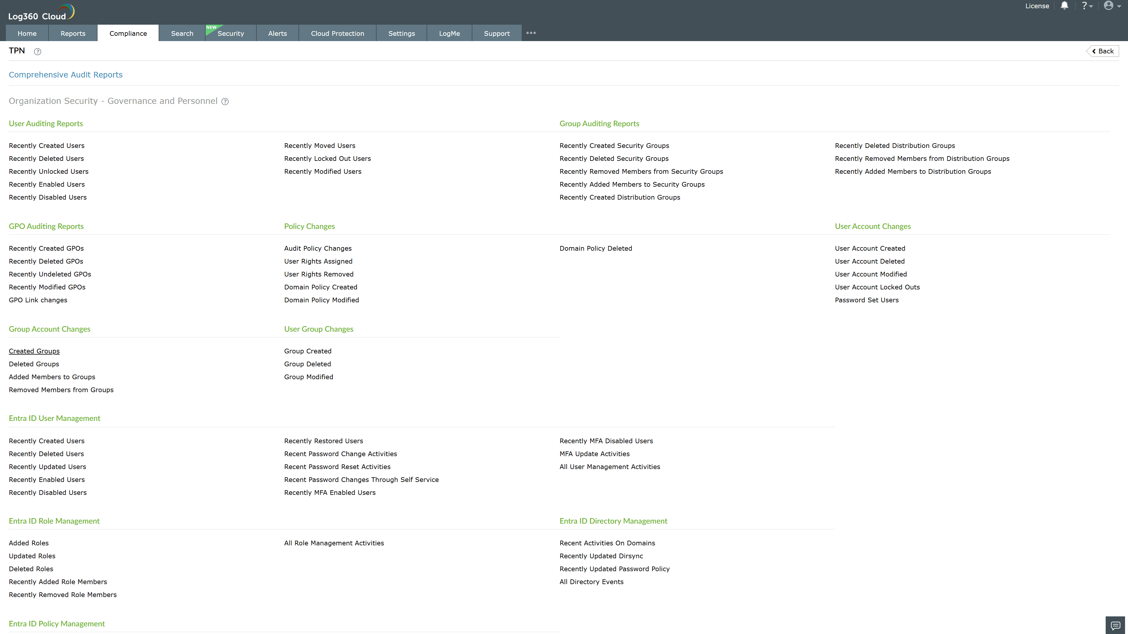
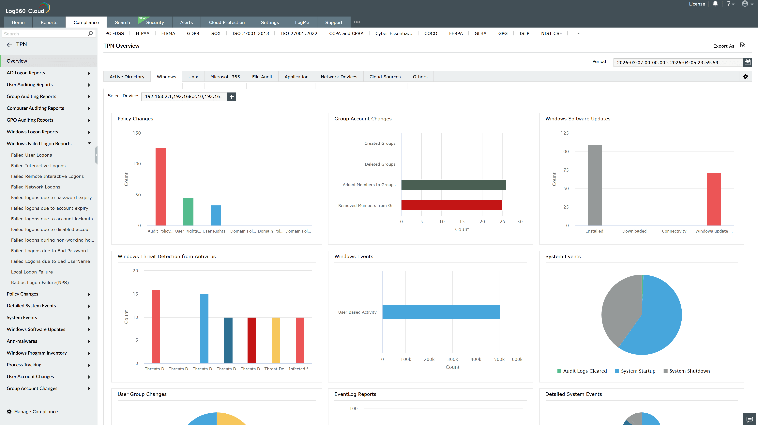
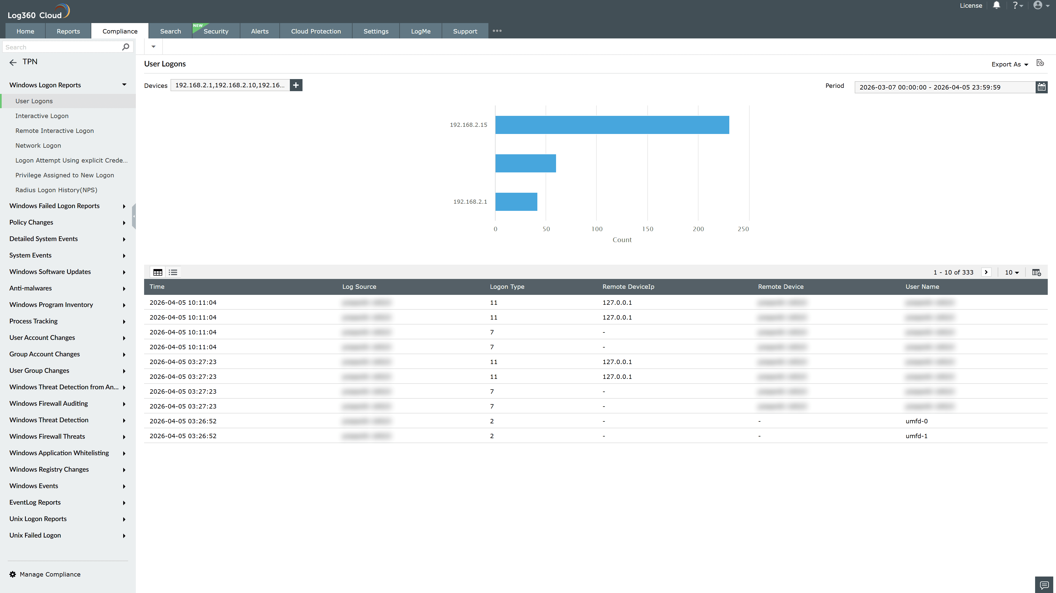
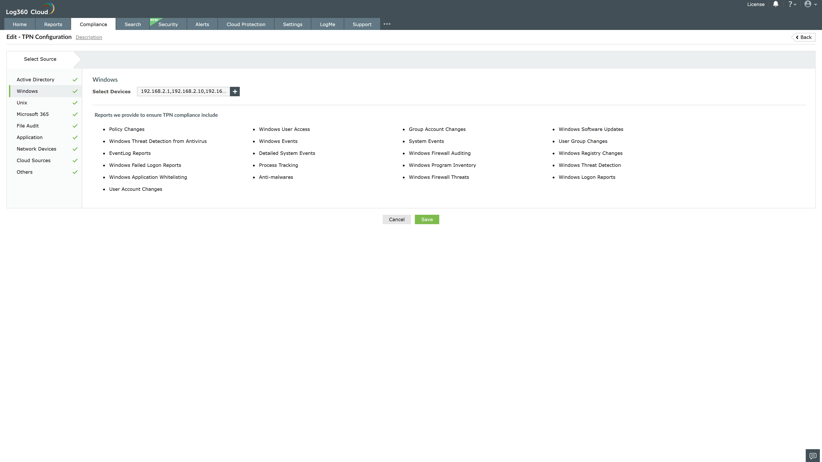
Valid Submission : Yes
Supported Editions : Free, Basic, Standard, Professional, MSSP
Help Document : https://www.manageengine.com/log-management/help/integrations/compliance-extensions.html
Help Video : Not provided
Tags : Log360, Compliance, Privacy monitoring, Data privacy, Regulatory compliance
Supported DCs : US, IN, JP, CA, AU, UK and EU
Privacy Policy:
Terms of Service:
Release Notes:
Predefined reports for the TPN.

